**Group 8 Iteration 2**

For iteration 2, we have developed an application model that captures the human body in 2d and marks landmarks according to the COCO topology. Our approach provides human pose tracking by employing machine learning (ML) to infer 33, 2D landmarks of a body from a single frame. Blaze Pose is particularly well-suited for fitness applications since it can precisely identify more key points. Furthermore, unlike current state-of-the-art methods that heavily rely on powerful desktop environments for processing, our approach achieves real-time performance on mobile phones using CPU inference.

The existing benchmark for determining human body posture is based on the COCO topology, which includes 17 key points located on the torso, arms, legs, and face. However, this topology only provides data for ankle and wrist points and fails to provide information regarding the scale and orientation of hands and feet. Such information is crucial for practical applications such as fitness and dance.

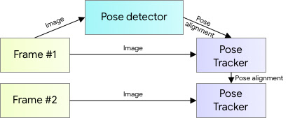

The above shows the pose detector module, where we take the frame and feed it to the pose detector algorithm which will return the pose tracker and pose alignment.

Things are which are done in this iteration

1. Developed a pose detection model, which captures the pose and landmarks which can be used to convert into a 3d model.

2. Created a web interface using the Streamlit library to display the output.

3. Evaluating 3d modelers such as Blender and Unity.

Errors faced we faced in this iteration 2:

1. Unable to connect the Blender API to model into a 3d human model

2. Faced a problem connecting the Web RTC with the API.

3. Incompatibility issues with Visualization libraries.

Output Screen Shots:

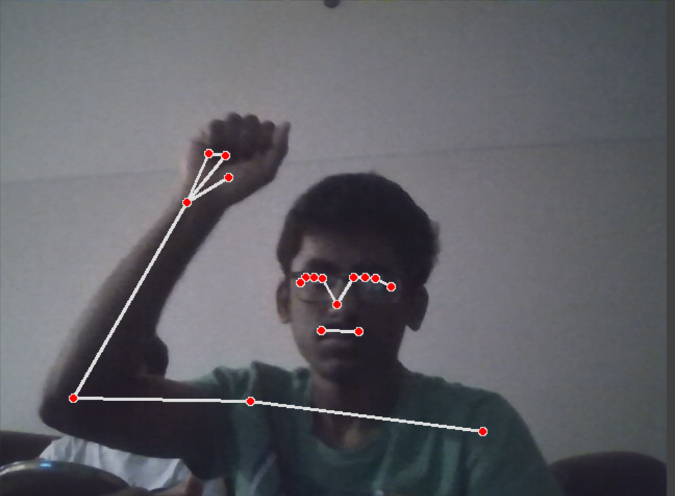

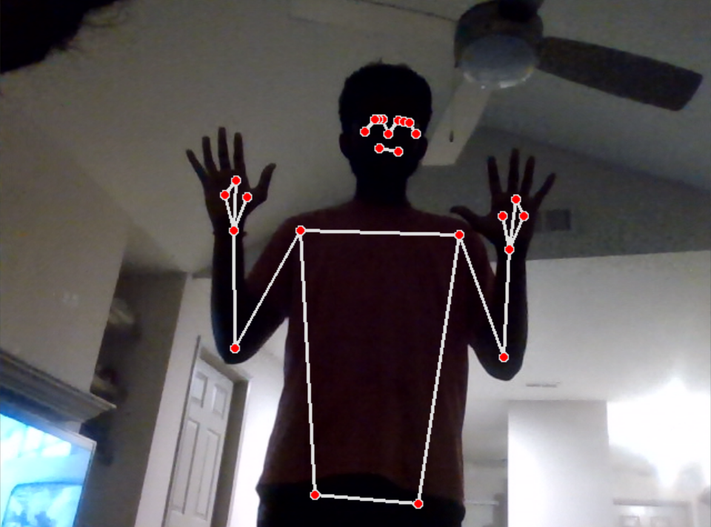s